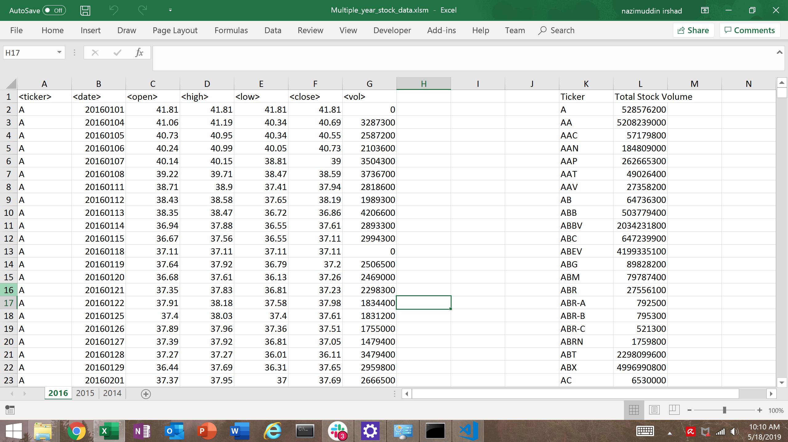

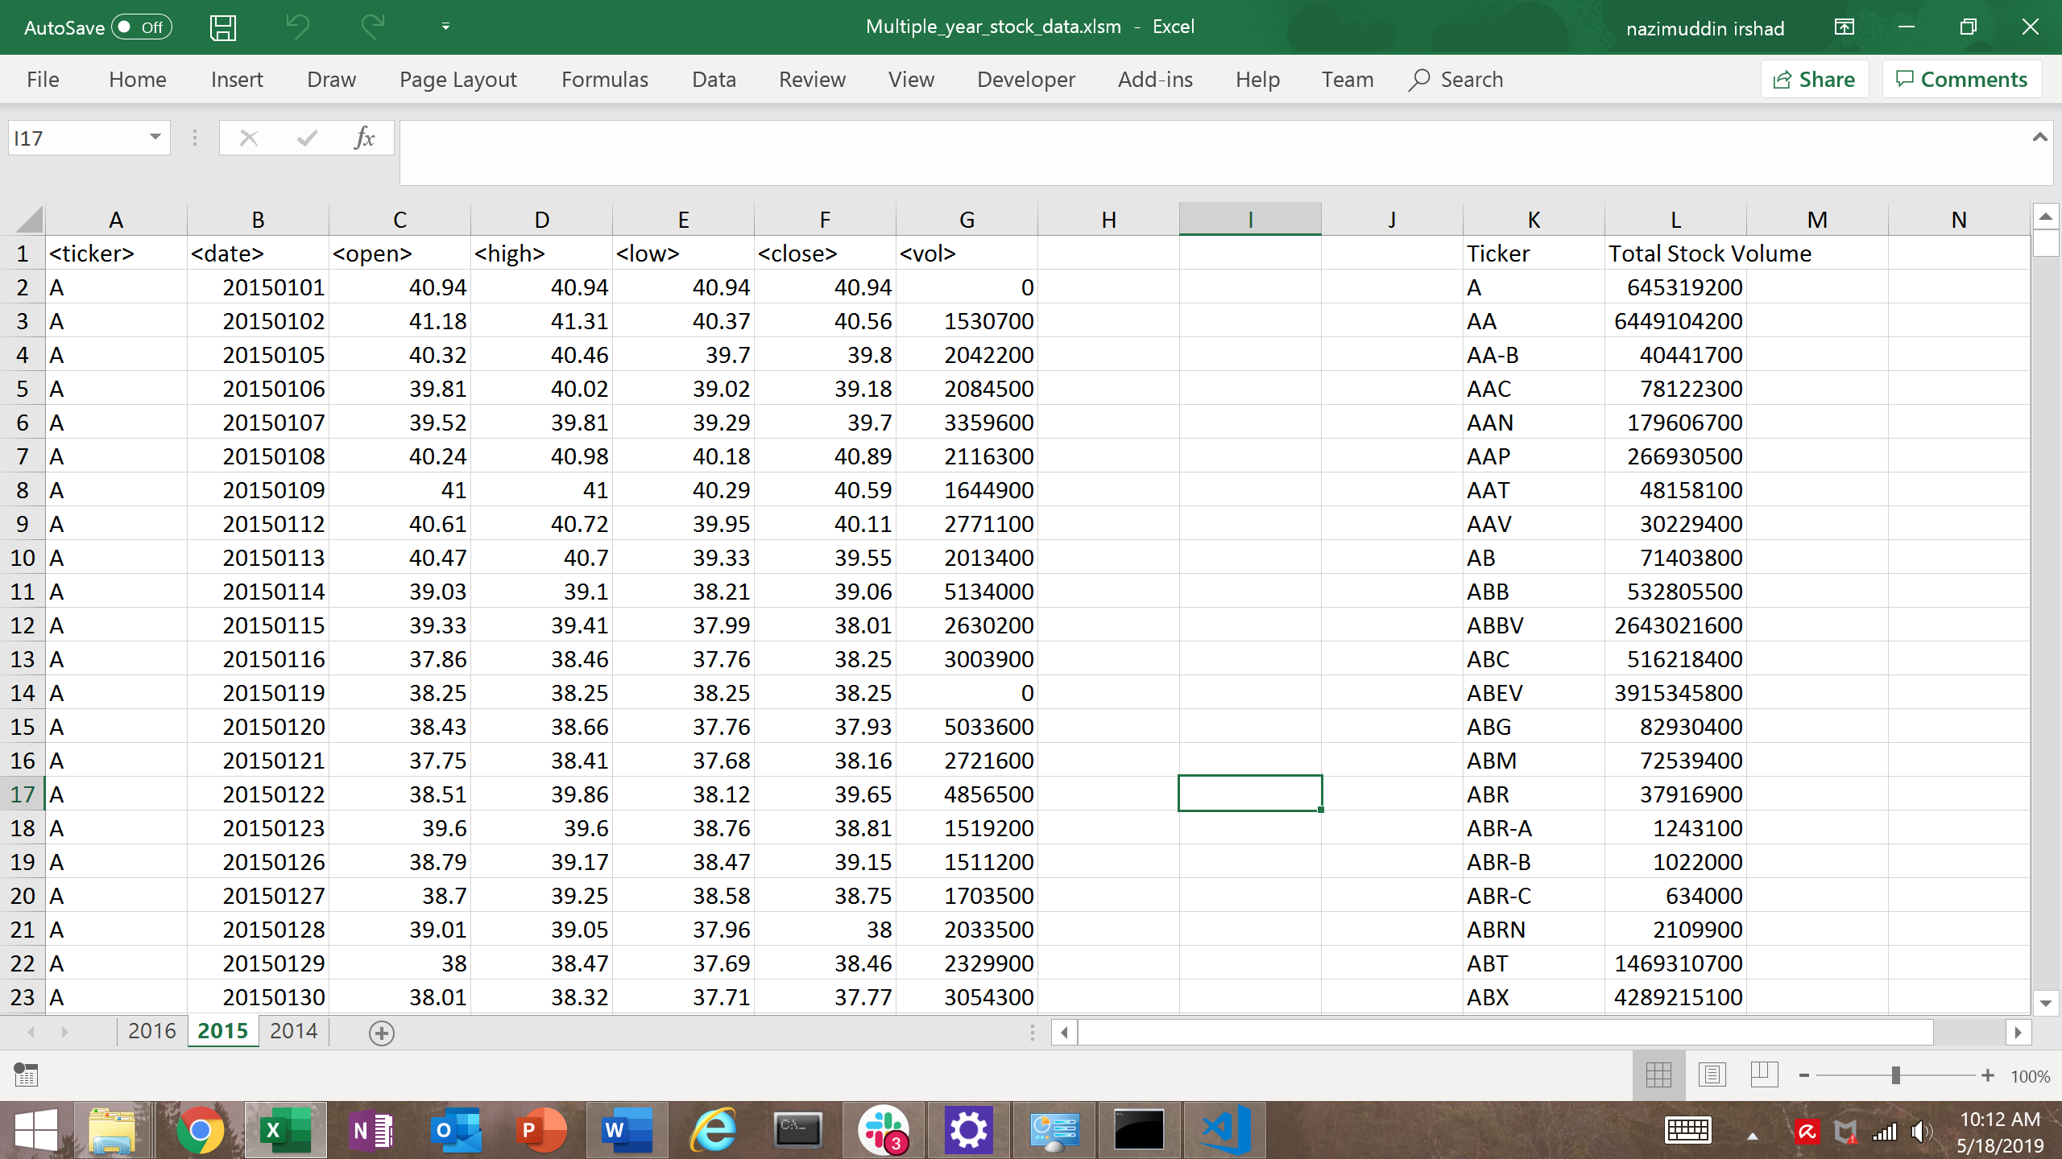

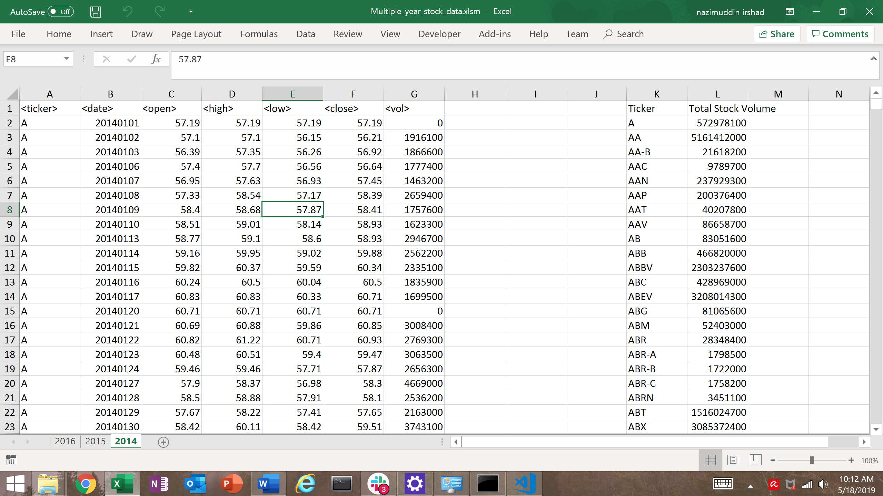

ub alphabet_testing()

' Define and set up variables

' Create worksheet

Dim ws As Worksheet

' Start Loop to loop through all worksheets (A-P)

For Each ws In Worksheets

' Activate worksheet

ws.Activate

' Set an initial variable for holding the alphabet ticker

Dim Ticker As String

' Set an initial variable for holding the Last Row of Worksheet

Dim LastRow As Long

' Set an initial variable for holding the total volume per alphabet ticker

Dim Total_Volume As Double

Total_Volume = 0

' Keep track of the location for each ticker in the summary table

Dim Summary_Table_Row As Integer

Summary_Table_Row = 2

'set headers

ws.Cells(1, 11).Value = "Ticker"

ws.Cells(1, 12).Value = "Total Stock Volume"

'Set Last Row of Worksheet

LastRow = Range("A" & Rows.Count).End(xlUp).Row

' Loop through all alphabets

For i = 2 To LastRow

' Check if we are still within the same alphabet ticker, if not...

If ws.Cells(i + 1, 1).Value <> ws.Cells(i, 1).Value Then

' Set the alphabet ticker

Ticker = ws.Cells(i, 1).Value

' Add to the Total Volume

Total_Volume = Total_Volume + ws.Cells(i, 7).Value

' Print the Alphabet Ticker in the Summary Table

Range("K" & Summary_Table_Row).Value = Ticker

' Print the Total Volume to the Summary Table

Range("L" & Summary_Table_Row).Value = Total_Volume

' Add one to the summary table row

Summary_Table_Row = Summary_Table_Row + 1

' Reset the Total Volume

Total_Volume = 0

' If the cell immediately following a row is the same alphabet ticker...

Else

' Add to the Total Volume

Total_Volume = Total_Volume + ws.Cells(i, 7).Value

End If

' Loop to next alphabet row

Next i

' Loop to next worksheet

Next ws

End Sub